**AGRI SMART – CROP RECOMMENDATION SYSTEM**

**INNOVATIVE PRODUCT DEVELOPMENT-1 REPORT**

|  |  |  |
| --- | --- | --- |
|  | **Submitted by** |  |

K.ASFIYA 21RH1A6730

B.SRAVANI 21RH1A6707

G.HARINI 22RH5A6703

S.AKSHAYA DEEPA 21RH1A6759

**UNDER THE GUIDANCE OF**

Ms. P.Nagalakshmi

Assistant Professor

Dept. of CSE-DS

***in partial fulfillment of the Academic Requirements for the Degree of***

**BACHELOR OF TECHNOLOGY**

**CSE-DATA SCIENCE**



MALLA REDDY ENGINEERING COLLEGE FOR WOMEN

**(Autonomous Institution-UGC, Govt. of India**)

**Accredited by NBA & NAAC with ‘A’ Grade**

**National Ranking by NIRF Innovation – Rank band (151-300), MHRD, Govt. of India**

Approved by AICTE, Permanently Affiliated to JNTUH, ISO 9001:2015 Certified Institution

**Maisammaguda, Dhulapally, Secunderabad, Kompally-500100.** www.mallareddyecw.com **2023-24**



## CERTIFICATE

**DEPARTMENT OF CSE-DS**

**CERTIFICATE**

This is to certify that the Innovative Product Development work **AGRI SMART – CROP RECOMMENDATION SYSTEM** carried out by K. Asfiya(21RH1A6730), B.Sravani

(21RH1A6707), G. Harini(22RH5A6703), S. Akshaya Deepa(21RH1A6759) in partial fulfillment for the award of the Degree of Bachelor of Technology in Computer Science and Engineering-Data Science to the Jawaharlal Nehru Technological University, Hyderabad is a record of bonafied work carried out under my guidance and supervision.

**SUPERVISER SIGNATURE HEAD OF DEPERTMENT-DS**

**Ms. P.Nagalakshmi Dr.V.Pradeep**

**Assistant Professor Professor**

**EXTERNAL EXAMINER**

**External Examiner**

## 

## DECLARATION

We hereby declare that the Innovative Product Development **AGRI SMART – CROP RECOMMENDATION SYSTEM** submitted to Malla Reddy Engineering College for Women affiliated to Jawaharlal Nehru Technological University, Hyderabad (JNTUH) for the award of the Degree of Bachelor of Technology in CSE-DS is a result of original research work done by us. It is further declared that the Innovative Product Development report or any part thereof has not been previously submitted to any University or Institute for the award of Degree.

Place: K. ASFIYA (21RH1A6730)

Date: B. SRAVANI (21RH1A6707)

### G. HARINI (22RH5A6703)

S. AKSHAYA DEEPA (21RH1A6759)

**ACKNOWLEDGEMENT**

We feel ourselves honored and privileged to place our warm salutation to our college **Malla Reddy Engineering College for Women and Department of Computer Science and Engineering** which gave us the opportunity to have expertise in engineering and profound technical knowledge.

We would like to deeply thank our Honorable Minister of Telangana State **Sri.Ch. Malla Reddy Garu**, founder chairman MRGI, the largest cluster of institutions in the state of Telangana for providing us with all the resources in the college to make our project success.

We wish to convey gratitude to our **Principal Dr. Y. Madhavee Latha**, for providing us with the environment and mean to enrich our skills and motivating us in our endeavor and helping us to realize our full potential.

We would like to thank **Prof. A. Radha Rani**, Director of Computer Science and Engineering & Information Technology for encouraging us to take up a project on this subject and motivating us towards the Project Work.

We express our sincere gratitude to **Dr.V. Pradeep**, Head of the Department of CSE –DS for inspiring us to take up a project on this subject and successfully guiding us towards its completion.

We would like to thank our **Ms. P.Nagalakshmi** , Assistant Professor and all the Faculty members for their valuable guidance and encouragement towards the completion of our project work.

**With Regards and Gratitude**

**K. ASFIYA (21RH1A6730)**

**B. SRAVANI (21RH1A6707)**

**G. HARINI (22RH5A6703)**

### S. AKSHAYA (21RH1A6759)

**ABSTRACT**

This abstract outlines the establishment of a crop recommendation system is a technology that helps farmers choose the right crops to grow by analyzing data like climate, soil, and past performance. It aims to boost productivity, save resources, reduce risk, and increase profits in agriculture. These systems are vital for sustainable and efficient farming.

this uses the machine learning algorithm like random forest to do so takes the nitrogen, phosphorous and other parameters and give the better readings according to that .

At last it recommend the best crop suitable for that particular environment

**INDEX**

1. **INTRODUCTION** 
   1. Project overview
   2. Objective
2. **LITERATURE SURVEY**
   1. Existing system
   2. Proposed System
   3. Advantages and Disadvantages
3. **AIM AND SCOPE OF PRESENT INVESTIGATION**
4. **METHODOLOGY**
5. **SOURCE CODE**
6. **RESULTS**
7. **CONCLUSION**
8. **FUTURE SCOPE**
9. **REFRENCES**

### 1.INTRODUCTION

In the world of developing technologies, the success of sharing information will help the agriculturists in realizing and developing their potential. The information sharing is that the valuable and timely information is being shared between agriculturists, either formally or informally. The willingness of information sharing refers to the open attitude among agriculturists. This open attitude determines the degree and scope of information sharing. Using web-technologies like html and css web application is build, create dataset by gathering data from multiple resources and place them in place which is used to predict the price of the crop and results are subjected to non-linear test later priorities are set and rankings are given to the list of crops. Place information in our application and share that information to agriculturists whose data is collected and stored in the mysql server. software to automatically send the updated information to the agriculturists in the form of text message. So that agriculturists no need to go to near by towns and cities to know the updated information. The machine learning algorithms is to predict the crop. For prediction purpose we can use Support vector machine(SVM), Naïve Baye’s (NB) and K-Nearest Neighbour(KNN) algorithms to predict the cost of the crop production. Further, a ranking process is applied for decision making in order to select the classifiers results.

**1.2 OBJECTIVE**

* Data set collection from various sources.
* Data parsing and cleansing technique is applied to make the raw data into processing data.
* The data collected is subject to machine learning system along with run time analysis makes an efficient crop value updation system.
* Usage of Ensemble of classifiers makes the model more robust and efficient.
* Ranking technique used in the project helps us to make efficient decisions.
* Creating a web application for user registrations and collection of data.
* The main objective is to obtain a better variety of crops that can be grown over the season. The proposed system would help to minimize the difficulties faced by farmers in choosing a crop and maximize the yield.
* The model predicts the crop yield by studying factors such as rainfall, temperature, area, season, soil type etc.

### 2.LITERATURE SURVEY

1. **Title: A Review on Data Mining Techniques for Fertilizer Recommendation 2018.**

**Authors : Jignasha M. Jethva, Nikhil Gondaliya, Vinita Shah**

To keep up nutrition levels in the soil in case of deficiency, fertilizers are added to soil. The standard issue existing among the Indian agriculturists choose approximate amount of fertilizers and add them manually. Excess or deficient extension of fertilizers can harm the plants life and reduce the yield. This paper gives overview of various data mining frameworks used on cultivating soil dataset for fertilizer recommendation.

1. **Title: A Survey on Data Mining Techniques in Agriculture, 2015.**

**Authors : M.C.S.Geetha**

Agriculture is the most critical application area especially in the developing nations like

India .Use of information technology in agriculture can change the situation of decision making

and farmers can yield in better way.. This paper integrates the work of several authors in a

single place so it is valuable for specialists to get data of current situation of data mining

systems and applications in context to farming field.

1. **Title : AgroNutri Android Application,2016.**

**Authors : S. Srija, R. Geetha Chanda, S.Lavanya, Dr. M. Kalpana Ph.D**

This paper communicates the idea regarding the making of AgroNutri an android application that helps in conveying the harvest particular fertilizer amount to be applied. The idea is to calculate the measure of NPK composts to be applied depend on the blanked proposal of the crop of interest. This application works depend on the product chosen by the farmer and that is taken as input, thus providing the farmers. The future scope of the AgroNutri is that GPRS can be included so that according to location nutrients are suggested.

1. **Title: Machine Learning: Applications in Indian Agriculture, 2016.**

**Authors: Karandeep Kaur**

Agriculture is a field that has been lacking from adaption of technologies and their advancements. Indian agriculturists should be up to the mark with the universal procedures. Machine learning is a native concept that can be applied to every field on all inputs and outputs. It has effectively settled its ability over ordinary calculations of software engineering and measurements. Machine learning calculations have improved the exactness of artificial intelligence machines including sensor based frameworks utilized in accuracy farming. This paper has evaluated the different uses of machine learning in the farming area. It additionally gives a knowledge into the inconveniences looked by Indian farmers and how they can be resolved using these procedures.

1. **Title: Impacts of population growth, economic development, and technical change on global food production and consumption, 2011.**

**Author: Uwe A. Schneider a,**⇑**, Petr Havlik b, Erwin Schmid c, Hugo Valin b,**

**Aline Mosnier b,c, Michael Obersteiner b, Hannes Bottcher b, Rastislav Skalsky´ d, Juraj Balkovicˇ d, Timm Sauer a, Steffen Fritz b**

Throughout the following decades humanity will request more food from less land and water assets. This investigation evaluates the food production effects of four elective advancement situations from the Millennium Ecosystem Assessment and the Special Report on Emission Scenarios. partialy and jointly considered are land and water supply impacts from population development, and specialized change, and forests and agriculture demand request shifts from population development and economic improvement. The income impacts on nourishment request are registered with dynamic flexibilities. Worldwide farming area increments by up to 14% somewhere in the range of 2010 and 2030.Deforestation restrictions strongly impact the price of land and water resources but have little consequences for the global level of food production and food prices. While projected income changes have the highest partial impact on per capita food consumption levels, population growth leads to the highest increase in total food production. The impact of technical change is amplified or mitigated by adaptations of land management intensities

1. **Title: Brief history of agricultural systems modelling,2016.**

**Author: James W. Jones a,⁎, John M. Antle b, Bruno O. Basso c, Kenneth J.**

**Boote a, Richard T. Conant d, Ian Foster e, H. Charles J. Godfray f, Mario**

**Herrero g, Richard E. Howitt h, Sander Jansseni, Brian A. Keating g, Rafael**

**Munoz-Carpena a, Cheryl H. Porter a, Cynthia Rosenzweig j, Tim R.Wheeler k**

Rural frameworks science creates information that enables analysts to consider complex issues or take educated farming choices. The rich history of this science represents the decent variety of frameworks and scales over which they work and have been contemplated. Demonstrating, a basic apparatus in agrarian frameworks science, has been expert by researchers from an extensive variety of controls, who have contributed ideas and instruments over six decades. As agrarian researchers currently consider the "people to come" models, information, and learning items expected to meet the inexorably mind boggling frameworks issues looked by society, it is vital to check out this history and its exercises to guarantee that we stay away from re-innovation and endeavor to think about all elements of related difficulties. To this end, we outline here the historical backdrop of rural frameworks demonstrating and distinguish exercises discovered that can help control the structure and advancement of up and coming age of farming framework apparatuses and techniques. Various past occasions joined with generally innovative advancement in different fields have unequivocally added to the development of farming framework demonstrating, including improvement of process-based bio-physical models of yields and domesticated animals, factual models dependent on verifiable perceptions, and financial streamlining and reproduction models at family unit and local to worldwide scales. Attributes of rural frameworks models have changed broadly relying upon the frameworks included, their scales, and the extensive variety of purposes that spurred their advancement and use by specialists in various controls. Late patterns in more extensive joint effort crosswise over establishments, crosswise over orders, and between people in general and private segments recommend that the stage is set for the significant advances in rural frameworks science that are required for the up and coming age of models, databases, learning items and choice emotionally supportive networks.

1. **Title: A Smart Agricultural Model by Integrating Iot, Mobile and Cloud-based Big Data Analytics, 2017.**

**Authors: S.Rajeswari, K.Suthendran, K.Rajkumar.**

In the cultivating field, the system models play a significant role to the enhancement of the agro-normal and money related conditions. In the proportions of benefits of the field and farm examinations to give the information and to recognize fitting and fruitful organization practices. It can recognize the organization to arrive managers and transversely over reality as long as the required soil, the board, environment, and money related information. Decision Support Systems (DSSs) use to make the information for the vermin the board, develop the officials. These systems are not using the impelled strategies to process the data. Thusly, use the adroit system thoughts to take the decisions for the issue. It expects a crucial activity in the comprehension of agronomic results, and their use as decision sincerely steady systems for farmers is extending.

1. **Title: An Overview of Internet of Things and Data Analytics in Agriculture: Benefits and Challenges, 2018.**

**Authors: Olakunle Elijah, Tharek Abdul Rahman, Igbafe Orikumhi, Chee Yen Leow, Nour Hindia.**

A blueprint of Iot and DA in agriculture has been shown in this paper. A couple of zones related to the association of Iot in agribusiness have been discussed in detail. The investigation of composing exhibits that there are clusters of work advancing being produced of Iot development that can be used to increase operational efficiency and gainfulness of plant and creatures. The benefits of Iot and DA, and open troubles have been identified and inspected in this paper. Iot is depended upon to offer a couple of benefits to the agribusiness division. Regardless, there are up 'til now different issues to be steered to make it moderate for close to nothing and medium-scale farmers. The key issues are security and cost. It is typical that as contention increases in the cultivating part

1. **Title: Circulation Mode Selection Based on Cost Analysis, 2017.**

**Authors: Xiurong Sun*, Jingshan Zhang, Chenglin Wang, Tao Zhang**

If every farmer and each average production base will join their optimal conditions in making cooperatives, it will accomplish economies of scale. Furthermore, producers will have an all the more favourable position in the plans with downstream firms (shipper or retailer).Second, the main customers of wholesale market are not inhabitants nearby who buy small quantities products but lower distributors or retailers. More redesigned transportation mode respects intensive attempt of new agrarian things, which prompts bolster the movement of new chain joint logistics and strengthen resource utilize and made logistics advantage quality. Refresh everything considered agrarian things spread. By then, regard the examination of gigantic worth control of standard things and achieve the mind blowing control to stream process.

1. **Title: Support Vector Machine-based Fuzzy Self-learning Control for Induction Machines, 2010.**

**Authors : Zongkai Shao**

Using support vector machine (SVM) is to realize the self learning of fuzzy inference system (FIS), based on a fast modified varying metric method (MDFP) and a support vector machine identifier (SVMI), a SVM-FIS self-learning controller for the threephase induction machine adjustable speed system has been designed. The proposed controller is not only of the advantages that FIS does not depend on the plant model, strong robustness, and adaptive self-learning ability, but also learning ability and generalization performance of SVM. The designed processes of SVM-FIS, MDFP, and SVMI algorithms have been described in details. Simulation results show the feasibility, correctness and effectiveness of the proposed control strategy, such as the excellent static and dynamic performances, and strong antiinterference ability.

1. **Title: Machine Learning Facilitated Rice Prediction in Bangladesh, 2015.**

**Authors: Mohammad Motiur Rahman, Naheena Haq, Rashedur M Rahman**

In this examination, self organising map (SOM) was utilized to group the information relationship between the information factors. After that chi-square test strategy was utilized to set up the level of reliance between the related variable qualities. It was discovered that the day by day outrageous climate conditions, for example, most extreme and least fluctuation in temperature, precipitation, dampness and wind speed were the principle drivers of product development, yield and wine quality

1. **Title: Support Vector Machine-Based Classification Scheme of Maize Crop, 2017.**

**Authors: Suhas S Athani, CH Tejeshwar**

This paper says about, advancement of a mechanized framework to distinguish and group weeds from the products would be of extraordinary help and we have proposed a set-up that decreases labour. We have considered pictures of maize edits as the informational index. Separating surface highlights of the picture and applying SVM (support vector machine) to arrange whether the given picture is a weed or a yield brought about a precision of 82%. The proposed framework gives a chance to investigate more about element extraction methods.

1. **Title: WITH MACHINE LEARNING ALGORITHMS FOR ESTIMATING WINTER WHEAT AREAS, 2017.**

**Authors: Y.Z. Pan2**

we utilize different kernel functions in the CPPI models to depict the connection between fractional winter wheat area and MODIS EVI time series data. We tried three straight and non-direct kernel functions, including linear regression, artificial neural system, and support vector machine.. For areas like DT where multiple crop types have comparative phenology cycles, ANN-CPPI is found to play out the best. The two crop types to be specific winter wheat and rapeseed, can be separated well. These tests give elective answers for the uses of CPPI in mixed areas.

**2.1 EXISTING SYSTEM**

The computational and data demands of structural price forecasting generally far exceed than what is routinely available in developing countries. Consequently, researchers often rely on parsimonious representations of price processes for their forecasting needs. Contemporary parsimonious form of price forecasting relies heavily on time series modelling. In time series modelling, past observations of the same variable are collected and analyzed to develop a model describing the underlying relationship. During the past few decades, much effort has been devoted to the development and improvement of time series forecasting models. Time series modelling requires less onerous data input for regular and up-to date price forecasting. Hence there is a need for better classification which would be an ensemble or hybrid classification model.

**2.2 PROPOSED SYSTEM**

In proposed system, the data analysis technology is used to update the crop yield rate change. The concept of this paper is to implement the crop selection method so that this method helps in solving many agriculture and farmers problems. This improves our Indian economy by maximizing the yield rate of crop production. Different types of land condition. So the quality of the crops are identified using ranking process. By this process the rate of the low quality and high quality crop is also intimated. The usage of ensemble of classifiers paves a path way to make a better decision on predictions due to the usage of multiple classifiers. Further, a ranking process is applied for decision making in order to select the classifiers results. This system is used to predict the cost of the fertilizers for further. This project uses Ensemble of classifiers such as Decision tree and Random forest classifier. In addition, this project uses Ranking technique.

**2.3 ADVANTAGES OF PROPOSED SYSTEM**

* + - Useful to people far away from towns/cities.
    - Better time efficiency.
    - Reduction of repeated work.

**2.4 DISADVANTAGES OF EXISTING SYSTEM**

* + - Efficiency is low.
    - The existing system which recommends crop yield is either hardware-based being costly to maintain, or not easily accessible.
    - Despite many solutions that have been recently proposed, there are still open challenges in creating a user-friendly application with respect to crop recommendation.
    - More number of repeated work.

**3.AIM AND SCOPE OF THE PRESENT INVESTIGATION**

**3.1 Aim:**

Our Aim from the project is to make a ML model which takes student data trains itself using various Machine Learning techniques and Algorithms(Random Forest, Decision Tree) and predict the yield and best fertilizer that suits for the crops in virtual environment by considering the overall factors that contribute in his overall yield.Secondly, to learn the required tech stacks and use it to make model with an python application and lastly to execute it get output about yield and best fertilizer for the crop.

**3.2 Scope:**

This Project can be used to get the student performance with more accuracy than any other model published earlier and we can also make some mobile or web application based on the model.

**4.EXPERIMENTAL OR MATERIALS AND METHODS,ALGORITHMS USED.**

**4.1 RANDOM FOREST ALGORITHM:**

Random Forest is a popular machine learning algorithm that belongs to the supervised learning technique. It can be used for both Classification and Regression problems in ML. It is based on the concept of ensemble learning**,** which is a process of combining multiple classifiers to solve a complex problem and to improve the performance of the model.

As the name suggests, ***"***Random Forest is a classifier that contains a number of decision trees on various subsets of the given dataset and takes the average to improve the predictive accuracy of that dataset."

Instead of relying on one decision tree, the random forest takes the prediction from each tree and based on the majority votes of predictions, and it predicts the final output.

The greater number of trees in the forest leads to higher accuracy and prevents the problem of over fitting.

Random Forest works in two-phase first is to create the random forest by combining N decision tree, and second is to make predictions for each tree created in the first phase.

The Working process can be explained in the below steps:

**Step-1:** Select random K data points from the training set.

**Step-2:** Build the decision trees associated with the selected data points.

**Step-3:** Choose the number N for decision trees that you want to build.

**Step-4:** Repeat Step 1 & 2.

**Step-5:** For new data points, find the predictions of each decision tree, and assign the new data points to the category that wins the majority votes.

**4.2 DECISION TREE:**

Decision Tree is a Supervised learning technique that can be used for both classification and Regression problems, but mostly it is preferred for solving Classification problems. It is a tree-structured classifier, where internal nodes represent the features of a dataset, branches represent the decision rules and each leaf node represents the outcome**.**

In a Decision tree, there are two nodes, which are the **Decision Node** and **Leaf Node.**

Decision nodes are used to make any decision and have multiple branches, whereas Leaf nodes are the output of those decisions and do not contain any further branches.

The decisions or the test are performed on the basis of features of the given dataset. It is a graphical representation for getting all the possible solutions to a problem/decision based on given conditions.

It is called a decision tree because, similar to a tree, it starts with the root node, which expands on further branches and constructs a tree-like structure.

In order to build a tree, we use the CART algorithm**,** which stands for Classification and Regression Tree algorithm**.**

A decision tree simply asks a question, and based on the answer (Yes/No), it further split the tree into subtrees.

The complete process can be better understood using the below algorithm:

**Step-1:** Begin the tree with the root node, says S, which contains the complete dataset.

**Step-2:** Find the best attribute in the dataset using Attribute Selection Measure (ASM).

**Step-3:** Divide the S into subsets that contains possible values for the best attributes.

**Step-4:** Generate the decision tree node, which contains the best attribute.

**Step-5:** Recursively make new decision trees using the subsets of the dataset created in step -3. Continue this process until a stage is reached where you cannot further classify the nodes and called the final node as a leaf node.

**4.3 SYSTEM ARCHITECTURE:**

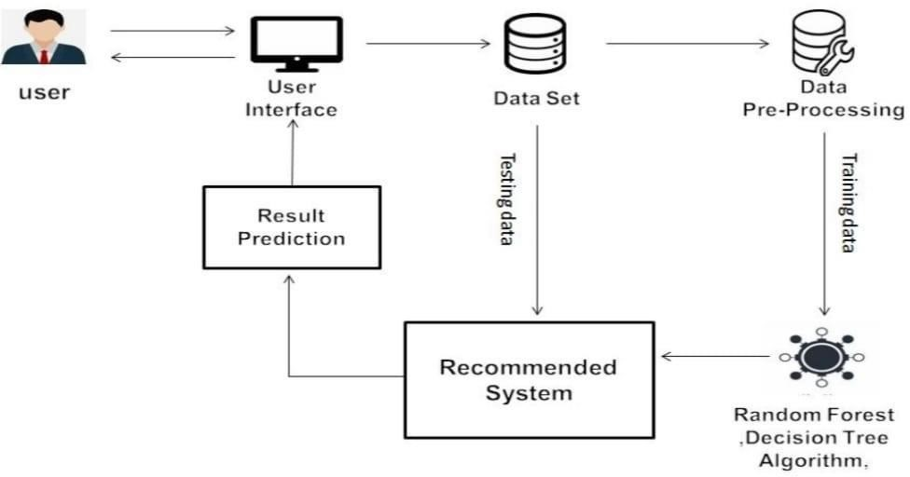

**4.4 SYSTEM REQUIREMENTS:**

**4.4.1 HARDWARE REQUIREMENTS:**

* + - * System: Pentium Dual Core.
      * Hard Disk: 40 GB.
      * Ram: 4 GB

**4.4.2 SOFTWARE REQUIREMENTS:**

* + - * Operating system: Windows 7/10.
      * Coding Language: Python.

**4.5 SOFTWARE ENVIRONMENT:**

**Python:**

Python is a high-level, interpreted, interactive and object-oriented scripting language. Python is designed to be highly readable. It uses English keywords frequently where as other languages use punctuation, and it has fewer syntactical constructions than other languages.

* + - **Python is Interpreted** − Python is processed at runtime by the interpreter. You do not need to compile your program before executing it. This is similar to PERL and PHP.
    - **Python is Interactive** − You can actually sit at a Python prompt and interact with the interpreter directly to write your programs.
    - **Python is Object-Oriented** − Python supports Object-Oriented style or technique of programming that encapsulates code within objects.
    - **Python is a Beginner's Language** − Python is a great language for the beginnerlevel programmers and supports the development of a wide range of applications from simple text processing to WWW browsers to games.

**History of Python:**

Python was developed by Guido van Rossum in the late eighties and early nineties at the National Research Institute for Mathematics and Computer Science in the Netherlands.

Python is derived from many other languages, including ABC, Modula-3, C, C++, Algol68, Smalltalk, and Unix shell and other scripting languages.

Python is copyrighted. Like Perl, Python source code is now available under the GNU General Public License (GPL).

Python is now maintained by a core development team at the institute, although Guido van Rossum still holds a vital role in directing its progress.

**Python Features:**

It includes:

* **Easy-to-learn** − Python has few keywords, simple structure, and a clearly defined syntax. This allows the student to pick up the language quickly.
* **Easy-to-read** − Python code is more clearly defined and visible to the eyes.
* **Easy-to-maintain** − Python's source code is fairly easy-to-maintain.
* **A broad standard library** − Python's bulk of the library is very portable and crossplatform compatible on UNIX, Windows, and Macintosh.
* **Interactive Mode** − Python has support for an interactive mode which allows interactive testing and debugging of snippets of code.
* **Portable/Scalable** − Python can run on a wide variety of hardware platforms and has the same interface on all platforms and better structure and support for large programs than shell scripting.
* **Extendable** − You can add low-level modules to the Python interpreter. These modules enable programmers to add to or customize their tools to be more efficient.
* **Databases** − Python provides interfaces to all major commercial databases.
* **GUI Programming** − Python supports GUI applications that can be created and ported to many system calls, libraries and windows systems, such as Windows

MFC, Macintosh, and the X Window system of Unix

**4.6 UML DIAGRAMS:**

UML is simply anther graphical representation of a common semantic model.

UML provides a comprehensive notation for the full lifecycle of object-oriented development.

**ADVANTAGES**

* To represent complete systems using object oriented concepts
* To establish an explicit coupling between concepts and executable code
* To take into account the scaling factors that are inherent to complex and Critical end.
* To creating a modelling language usable by both humans and machines UML defines several models for representing systems
* The class model captures the static structure
* The state model expresses the dynamic behavior of objects
* The use case model describes the requirements of the user
* The interaction model represents the scenarios and messages flows
* The implementation model shows the work units
* The deployment model provides details that pertain to process .

**4.7 DATA FLOW DIAGRAM:**

The DFD is also called as bubble chart. It is a simple graphical formalism that can be used to represent a system in terms of input data to the system, 24 various processing carried out on this data, and the output data is generated by this system.

The data flow diagram (DFD) is one of the most important modeling tools. It is used to model the system components. These components are the system process, the data used by the process, an external entity that interacts with the system and the information flows in the system.

DFD shows how the information moves through the system and how it is modified by a series of transformations. It is a graphical technique that depicts information flow and the transformations that are applied as data moves from input to output.

DFD is also known as bubble chart. A DFD may be used to represent a system at any level of abstraction. DFD may be partitioned into levels that represent increasing information flow and functional detail.

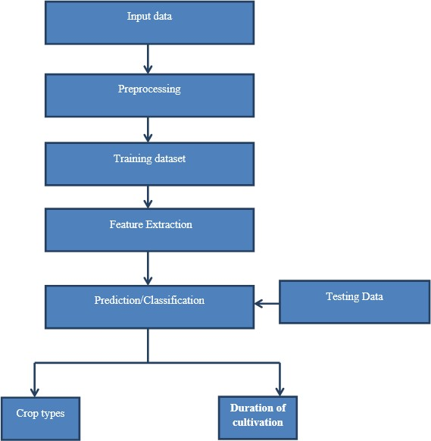

**4.7.1 USE CASE DIAGRAM**

Use case diagrams overview the usage requirement for system. They are useful for presentations to management and/or project stakeholders, but for actual development you will find that use cases provide significantly more value because they describe “the meant” of the actual requirements. A use case describes a sequence of action that provides something of measurable value to an action and is drawn as a horizontal ellipse.

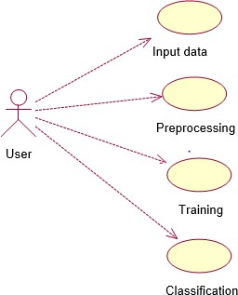

**4.7.2 ACTIVITY DIAGRAM:**

Activity diagram are graphical representations of workflow of stepwise activities and actions with support for choice, iteration and concurrency. The activity diagrams can be used to describe the business and operational step-by-step workflows of components in a system. Activity diagram consist of Initial node, activity final node and activities in between.

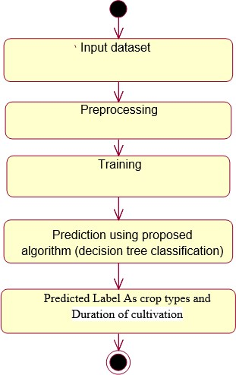

**4.8 INPUT DESIGN:**

The input design is the link between the information system and the user. It comprises the developing specification and procedures for data preparation and those steps are necessary to put transaction data in to a usable form for processing can be achieved by inspecting the computer to read data from a written or printed document or it can occur by having people keying the data directly into the system. The design of input focuses on controlling the amount of input required, controlling the errors, avoiding delay, avoiding extra steps and keeping the process simple. The input is designed in such a way so that it provides security and ease of use with retaining the privacy. Input Design considered the following things:

What data should be given as input?

How the data should be arranged or coded?

The dialog to guide the operating personnel in providing input.

Methods for preparing input validations and steps to follow when error occur.

**OBJECTIVES:**

1. Input Design is the process of converting a user-oriented description of the input into a computer-based system. This design is important to avoid errors in the data input process and show the correct direction to the management for getting correct information from the computerized system.
2. It is achieved by creating user-friendly screens for the data entry to handle large volume of data. The goal of designing input is to make data entry easier and to be free from errors. The data entry screen is designed in such a way that all the data manipulates can be performed. It also provides record viewing facilities.
3. When the data is entered it will check for its validity. Data can be entered with the help of screens. Appropriate messages are provided as when needed so that the user will not be in maize of instant. Thus the objective of input design is to create an input layout that is easy to follow

**4.9 OUTPUT DESIGN:**

A quality output is one, which meets the requirements of the end user and presents the information clearly. In any system results of processing are communicated to the users and to other system through outputs. In output design it is determined how the information is to be displaced for immediate need and also the hard copy output. It is the most important and direct source information to the user. Efficient and intelligent output design improves the system’s relationship to help user decision-making.

1. Designing computer output should proceed in an organized, well thought out manner; the right output must be developed while ensuring that each output element is designed so that people will find the system can use easily and effectively. When analysis design computer output, they should Identify the specific output that is needed to meet the requirements.
2. Select methods for presenting information.

1. Create document, report, or other formats that contain information produced by the system.

The output form of an information system should accomplish one or more of the following objectives.

* + - Convey information about past activities, current status or projections of the
    - Future.
    - Signal important events, opportunities, problems, or warnings.
    - Trigger an action.
    - Confirm an action.

**4.10 SYSTEM STUDY:**

**FEASIBILITY STUDY:**

The feasibility of the project is analyzed in this phase and business proposal is put forth with a very general plan for the project and some cost estimates. During system analysis the feasibility study of the proposed system is to be carried out. This is to ensure that the proposed system is not a burden to the company. For feasibility analysis, some understanding of the major requirements for the system is essential.

Three key considerations involved in the feasibility analysis are

♦ ECONOMICAL FEASIBILITY

♦ TECHNICAL FEASIBILITY

♦ SOCIAL FEASIBILITY

**ECONOMICAL FEASIBILITY:**

This study is carried out to check the economic impact that the system will have on the organization. The amount of fund that the company can pour into the research and development of the system is limited. The expenditures must be justified. Thus the developed system as well within the budget and this was achieved because most of the technologies used are freely available. Only the customized products had to be purchased.

**TECHNICAL FEASIBILITY:**

This study is carried out to check the technical feasibility, that is, the technical requirements of the system. Any system developed must not have a high demand on the available technical resources. This will lead to high demands on the available technical resources. This will lead to high demands being placed on the client. The developed system must have a modest requirement, as only minimal or null changes are required for implementing this system.

**SOCIAL FEASIBILITY:**

The aspect of study is to check the level of acceptance of the system by the user. This includes the process of training the user to use the system efficiently. The user must not feel threatened by the system, instead must accept it as a necessity. The level of acceptance by the users solely depends on the methods that are employed to educate the user about the system and to make him familiar with it. His level of confidence must be raised so that he is also able to make some constructive criticism, which is welcomed, as he is the final user of the system.

**SYSTEM TESTING:**

The purpose of testing is to discover errors. Testing is the process of trying to discover every conceivable fault or weakness in a work product. It provides a way to check the functionality of components, sub assemblies, assemblies and/or a finished product It is the process of exercising software with the intent of ensuring that the

Software system meets its requirements and user expectations and does not fail in an unacceptable manner. There are various types of test. Each test type addresses a specific testing requirement.

**TYPES OF TESTS:**

**Unit testing:**

Unit testing involves the design of test cases that validate that the internal program logic is functioning properly, and that program inputs produce valid outputs. All decision branches and internal code flow should be validated. It is the testing of individual software units of the application .it is done after the completion of an individual unit before integration. This is a structural testing, that relies on knowledge of its construction and is invasive. Unit tests perform basic tests at component level and test a specific business process, application, and/or system configuration. Unit tests ensure that each unique path of a business process performs accurately to the documented specifications and contains clearly defined inputs and expected results.

**Integration testing:**

Integration tests are designed to test integrated software components to determine if they actually run as one program. Testing is event driven and is more concerned with the basic outcome of screens or fields. Integration tests demonstrate that although the components individually satisfaction, as shown by successfully unit testing, the combination of components is correct and consistent. Integration testing is specifically aimed at exposing the problems that arise from the combination of components.

**Functional test:**

Functional tests provide systematic demonstrations that functions tested are available as specified by the business and technical requirements, system documentation, and user manuals.

Functional testing is centered on the following items:

|  |  |
| --- | --- |
| Valid Input | : identified classes of valid input must be accepted. Invalid |
| Input | : identified classes of invalid input must be rejected. |
| Functions | : identified functions must be exercised. |
| Output | : identified classes of application outputs must be exercised. |

Systems/Procedures: interfacing systems or procedures must be invoked.

Organization and preparation of functional tests is focused on requirements, key functions, or special test cases. In addition, systematic coverage pertaining to identify Business process flows; data fields, predefined processes, and successive processes must be considered for testing. Before functional testing is complete, additional tests are identified and the effective value of current tests is determined.

**System Test:**

System testing ensures that the entire integrated software system meets requirements. It tests a configuration to ensure known and predictable results. An example of system testing is the configuration oriented system integration test.System testing is based on process descriptions and flows, emphasizing pre-driven process links and integration points.

**White Box Testing:**

#### White Box Testing is a testing in which in which the software tester has knowledge

of the inner workings, structure and language of the software, or at least its purpose. It is purpose. It is used to test areas that cannot be reached from a black box level.

**Black Box Testing:**

Black Box Testing is testing the software without any knowledge of the inner workings, structure or language of the module being tested. Black box tests, as most other kinds of tests, must be written from a definitive source document, such as specification or requirements document, such as specification or requirements document. It is a testing in which the software under test is treated, as a black box

.you cannot “see” into it. The test provides inputs and responds to outputs without considering how the software works.

**Unit Testing:**

Unit testing is usually conducted as part of a combined code and unit test phase of the software lifecycle, although it is not uncommon for coding and unit testing to be conducted as two distinct phases.

**Test strategy and approach**

Field testing will be performed manually and functional tests will be written in detail.

**Test objectives:**

* All field entries must work properly.
* Pages must be activated from the identified link.
* The entry screen, messages and responses must not be delayed.

**Features to be tested:**

* Verify that the entries are of the correct format
* No duplicate entries should be allowed
* All links should take the user to the correct page

**Integration Testing:**

Software integration testing is the incremental integration testing of two or more integrated software components on a single platform to produce failures caused by interface defects.

The task of the integration test is to check that components or software applications, e.g. components in a software system or – one step up – software applications at the company level – interact without error.

**Test Results:** All the test cases mentioned above passed successfully. No defects encountered.

**Acceptance Testing:**

User Acceptance Testing is a critical phase of any project and requires significant participation by the end user. It also ensures that the system meets the functional requirements.

**Test Results:** All the test cases mentioned above passed successfully. No defects encountered.

**5. SOURCE CODE**

'''create a folder in the desktop dedicated to this IPD Project. Here we will save the work .we are

writing this in the Jupyter notebook one can also do it in google collab or directly in VS

code/python before that we pip install the streamlit for showing the work in form of application

before import.Here we use Jupyter notebook and then import it to VS code.'''

#code

#import all packages we need import numpy as np

import pandas as pd import streamlit as st

from sklearn.model_selection

import train_test_split from sklearn.ensemble

import RandomForestClassifier

from sklearn.preprocessing import MinMaxScaler

from sklearn.preprocessing import StandardScaler import time

import streamlit as st #funtion for main prediction

def recommendation(n,p,k,temp,hum,ph,rain):

features = np.array([[n,p,k,temp,hum,ph,rain]]) :

transformed_features = ms.fit_transform(features)

transformed_features = sc.fit_transform(transformed_features)

prediction = rfc.predict(transformed_features).reshape(1,-1) return prediction[0]

st.title("Agri Smart : Crop Recommendation System")

from PIL import Image

if submitted:

if predict[0] in crop_dict:

crop = crop_dict[predict[0]]

st.title("{} is a best crop to be cultivated ".format(crop))

image = Image.open('crops-growing-in-thailand.jpg')

st.image(image,caption='Happyfarming')

else:

st.title("Sorry are not able to recommend a proper crop for this environment")

image2 = Image.open('smiley.jpg')

st.image2(image, caption='please change the inputs and try again')

**6.RESULTS AND DISCUSSIONS:**

In this project the data analysis technology is used to update the rate change through notification. Further, a ranking process is applied for decision making

in order to select the classifiers results. This system is used to predict the cost of the crop

**6.1 SCREENSHOTS**

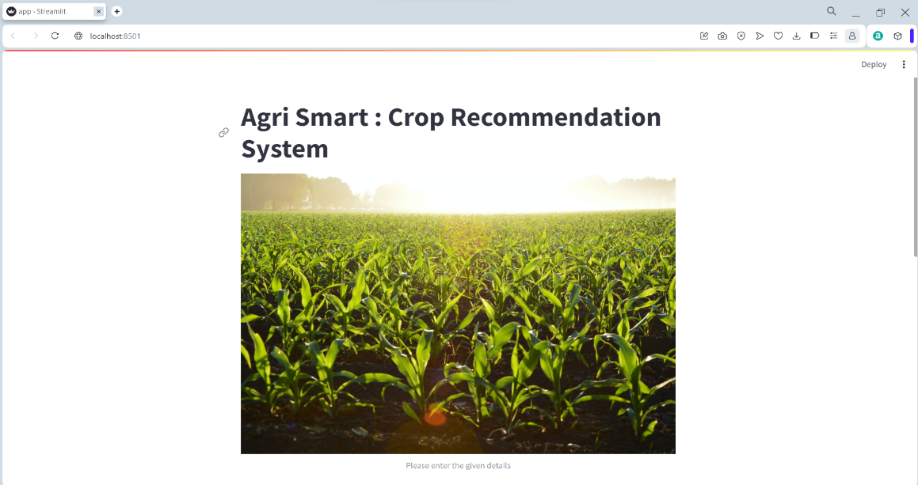

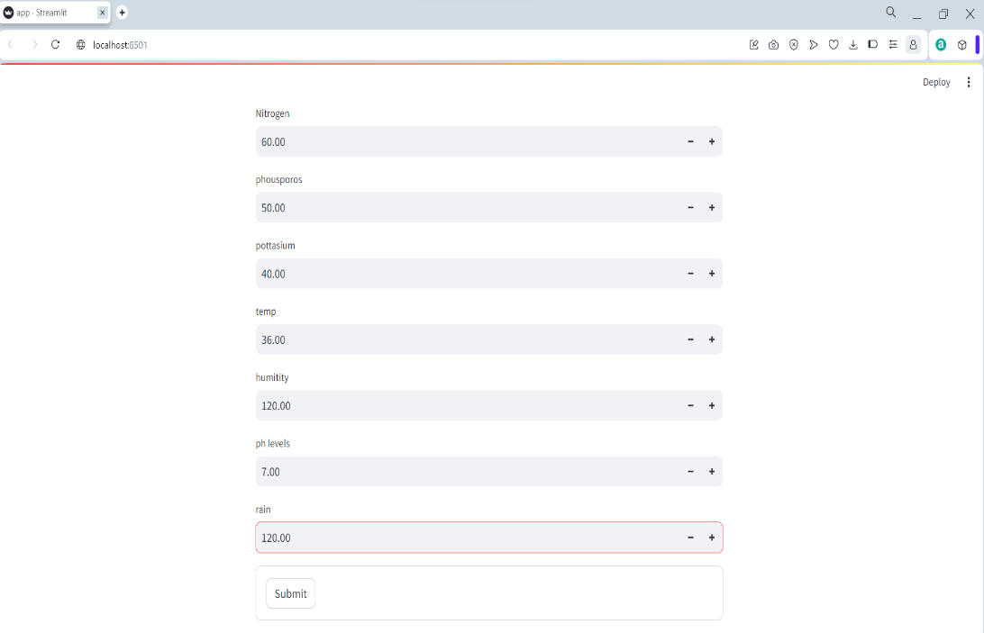

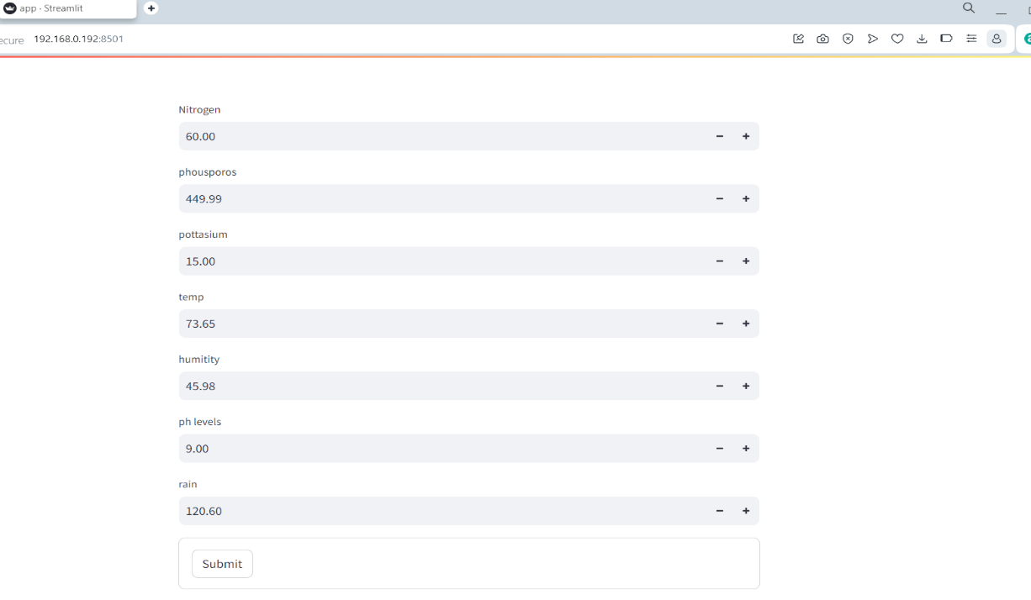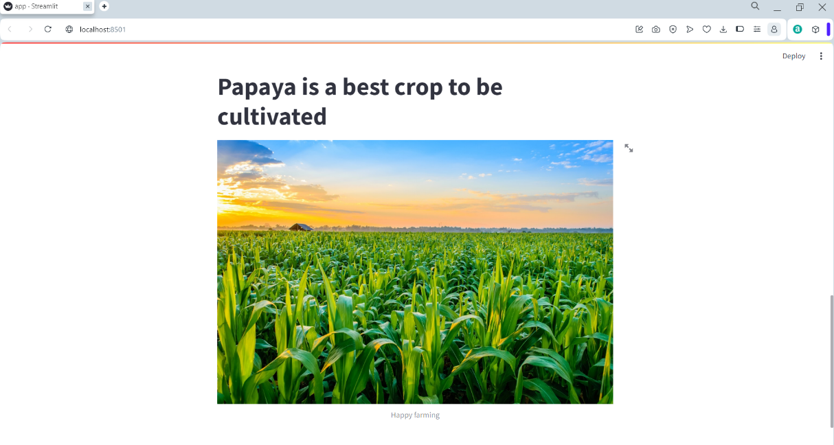

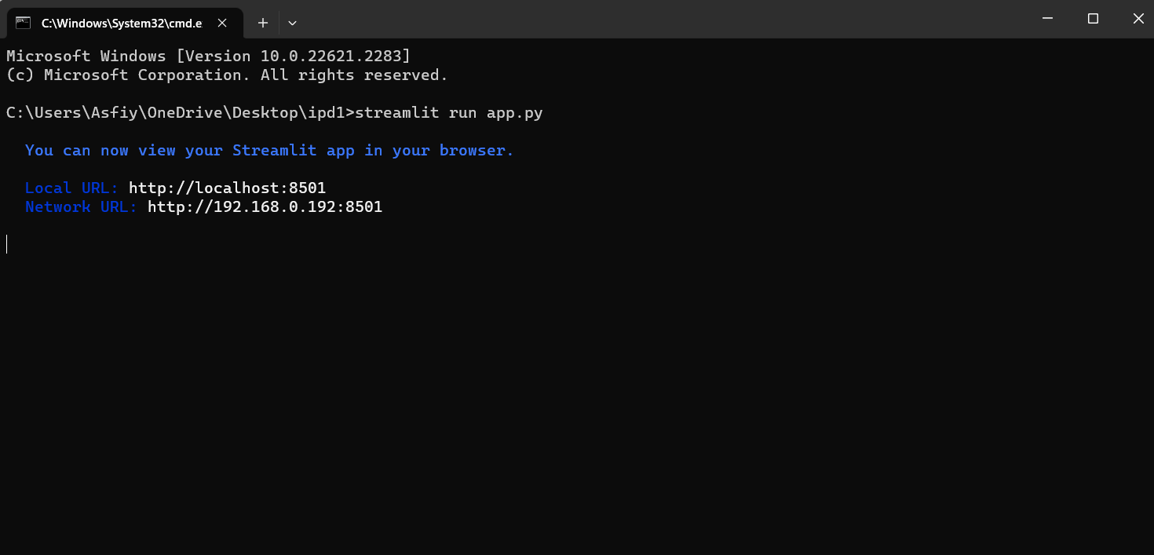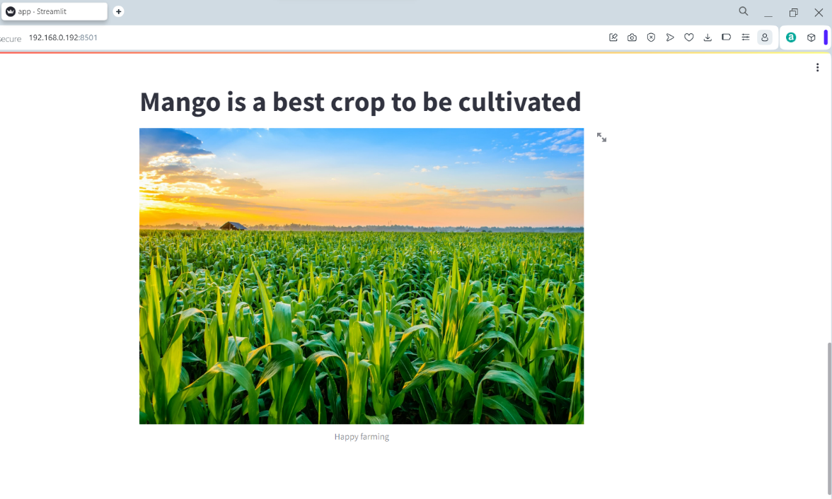

### 7. CONCLUSION

This open attitude determines the degree and scope of information sharing. Big data analysis technology can effectively improve the crop yield production is updation. This project proposes a novel intelligent system for agricultural crop price prediction. The key idea is to use ensemble of classifiers for prediction. The usage of ensemble of classifiers paves a path way to make a better decision on predictions due to the usage of multiple classifiers. Further, a ranking process is applied for decision making in order to select the classifiers results. This system is used to predict the cost of the crop rate for further.

The solution will benefit farmers to maximize productivity in agriculture, reduce soil degradation in cultivated fields, and reduce fertilizer use in crop production by recommending the right crop by considering various attributes.

This would provide a comprehensive prediction on the basis of geographical, environmental and economic aspects.

### 8.FUTURE SCOPE

Crop recommendation systems can integrate with precision agriculture Technologies,

such as sensors, drones, and satellite imagery. This can provide real-time data for better

monitoring and decision-making, allowing farmers to adjust their practices dynamically.

Adding more of the new ideas to this recommendation system like live recording,soil

classification,soil determination and other real time experiments can be done

As machine learning algorithms continue to advance, crop recommendation systems can

become more sophisticated and accurate. Deep learning models and neural networks can be

employed to analyze complex relationships between various environmental factors and crop

performance, leading to more precise recommendations.

Integration of data from different sources, such as weather stations, soil sensors, and

historical crop data, can enhance the accuracy of recommendations. Interoperability between

different agricultural technologies and data platforms can streamline information flow for

better decision-making.

With the increasing impact of climate change on agriculture, crop recommendation systems

can play a vital role in helping farmers adapt to changing conditions. These systems can

provide recommendations based on predicted climate patterns, helping farmers

choose crops that are more resilient to specific environmental challenges.

The widespread use of mobile devices in rural areas allows for the development of user-

friendly mobile applications that farmers can use to access crop recommendations. Internet

of Things (IoT) devices can also play a role in collecting real-time data from the field and

Transmitting it to the recommendation system

### 9. REFERENCES

1. Manpreet Kaur, Heena Gulati, Harish Kundra, “Data Mining in Agriculture on Crop

Price Prediction: Techniques and Applications”, International Journal of Computer Applications, Volume 99– No.12, August 2014.

1. J. Meng, “Research on the cost of agricultural products circulation and its control under the new normal economic development,” Commercial Times, no. 23, pp. 145147, 2016.
2. A. Kaloxylos et al., “Farm management systems and the future Internet era,” Comput. Electron. Agricult., vol. 89, pp. 130–144, Nov. 2012.
3. N. N. Li, T. S. Li, Z. S. Yu, Y. Rui, Y. Y. Miao, and Y. S. Li, “Factors influencing farmers’ adoption of new technology based on Logistic-ISM model-a case study of potato planting technology in Dingxi City, Gansu Province,” Progress in Geography, vol. 33, no. 4, pp. 542-551, 2014.
4. Y. Wang, "A neural network adaptive control based on rapid learning method and its application," Advances In Modeling and Analysis, Vol. 46(3), pp. 27-34,1994.